# [***Law & Order: SVU Vet Blasts 'Clownass MFs Trying to Make Up' Feud Drama***](https://tvline.com/2023/01/16/ice-t-chris-meloni-feud-law-and-order-svu-taboid-report/)

By [Michael Ausiello](https://tvline.com/author/michael-ausiello/) / January 16 2023, 1:26 PM PST

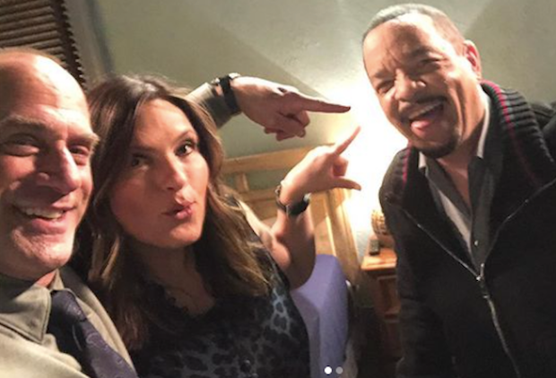

Courtesy of Instagram

Two veterans of Dick Wolf’s *Law & Order* universe are getting out ahead of a forthcoming tabloid report alleging a feud between the pair.

Longtime [*Law & Order: SVU*](https://tvline.com/tag/law-and-order-svu/) cast member Ice-T [posted on Twitter Monday a letter](https://twitter.com/FINALLEVEL/status/1615083963747368999) he claims was sent to him by *The National Enquirer*, in which the tabloid requests comment on a forthcoming story stating that he and co-star Chris Meloni “are feuding since the latter’s [2021] return to the franchise” via [*Law & Order: Organized Crime*](https://tvline.com/tag/law-and-order-organized-crime/).

“Sources told *The Enquirer* that the former rapper has grown envious of the attention that Mr. Meloni has received since coming back,” the missive continued.

In making the note public, Ice-T flatly denied the accusation, tweeting, “Clownass MFs trying to make up Drama outta thin air… WOW… MFs are really on that BS.”

Ice-T shared the purported email with Meloni, who had this tongue-in-cheek reaction via Twitter: Ice-T “was kind enough to let me know we were feuding.”

Prior to reprising his role as Stabler in *Organized Crime*, Meloni spent 12 seasons on *SVU*, 11 of them opposite Ice-T. Both actors have remained in each others’ orbit courtesy of NBC’s semi-regular *SVU/Organized Crime* crossover events.

TVLine has reached out to *The National Enquirer* for comment*.*